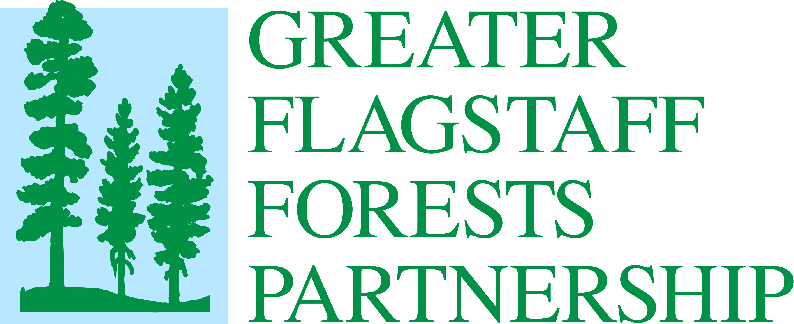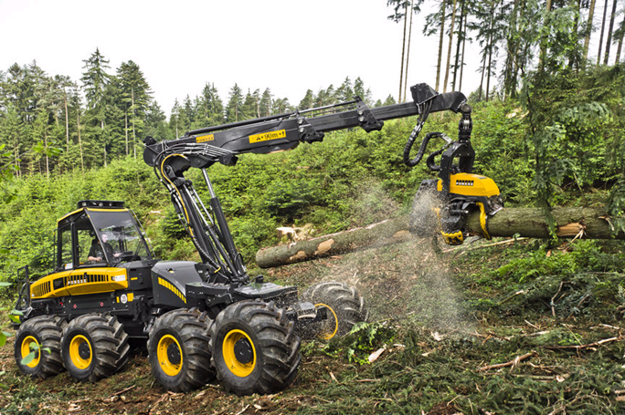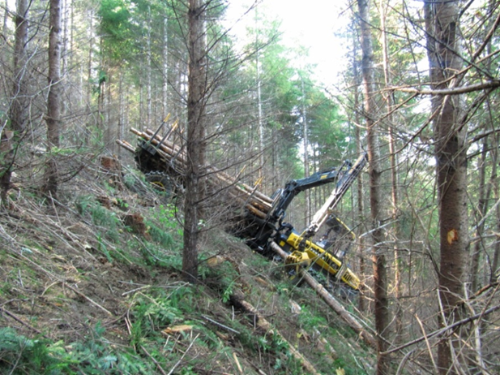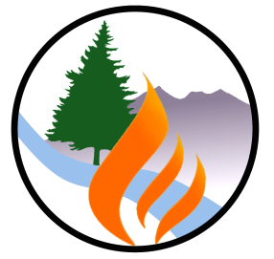

LOGGING

* Approximately 320 acres (4% of treated acres) is planned for steep slope ground based equipment logging.

#### FWPP Project

*This institution is an equal opportunity provider.*

**Capabilities**

* Recent technological advances allow this equipment to operate on steep slopes up to 65% grade. By comparison, normal ground based harvesting equipment is limited to slopes of 40% or less.

• To minimize impacts to the soil, limbs and tops may be left in the paths used by the equipment.

• Whole trees, including the limbs and tops, may be loaded onto the forwarder and moved to a landing for further processing and disposal.

**Limitations**

• Extremely rocky terrain, especially on steep slopes, can limit use and/or operability.

• Requires a road system (temporary roads most common).

**Advantages**

• Steep slope equipment may be used in areas that would otherwise have to be cable or helicopter logged.

• Workers are protected within a reinforced cab allowing for the retention of most standing dead trees (valuable to wildlife).

**What is Steep Slope Ground Based Logging?**

Steep slope ground based equipment logging, sometimes called “Cut to Length” logging, consists of using two machines: 1) a harvester that cuts, de-limbs, and processes timber into logs, and 2) a forwarder that loads and carries the logs from the cutting area to a designated roadside landing.

*“Harvester” cutting trees to length*

*“Forwarder” moving cut trees*

* Less than helicopter logging.
* More than ground based logging.

### **Costs**

STEEP SLOPE

GROUND BASED

Flagstaff watershed Protection Project (FWpp)